1. Setting all hosts

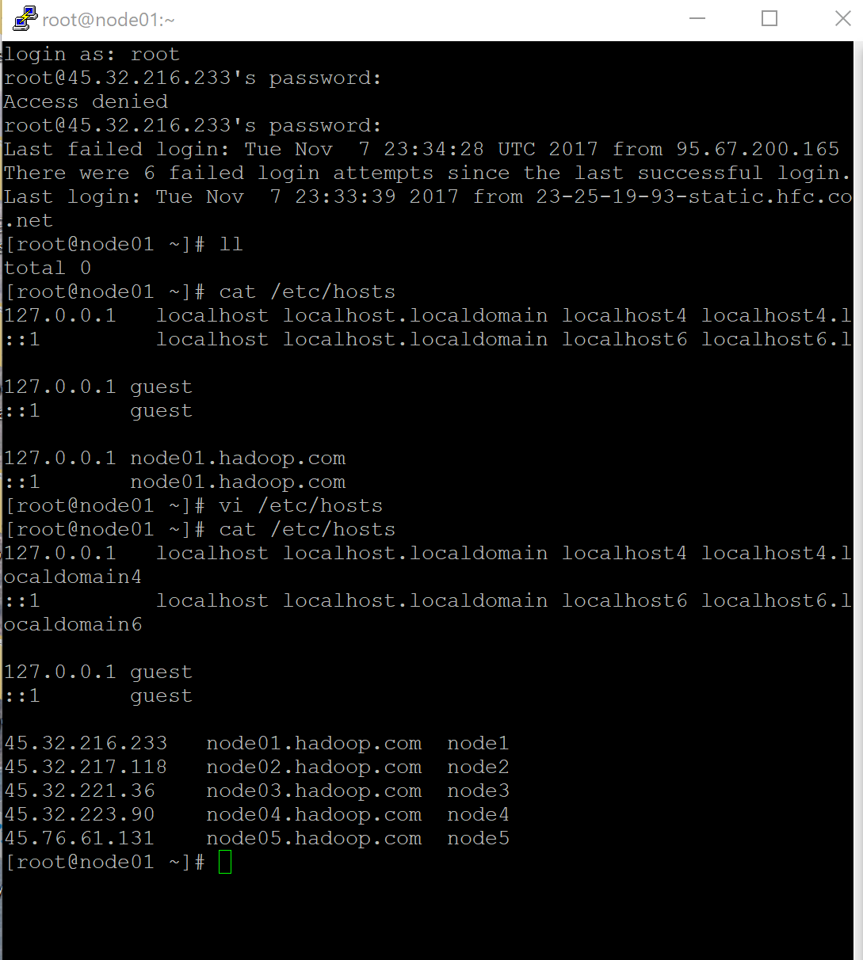

1. Pinging the node to check

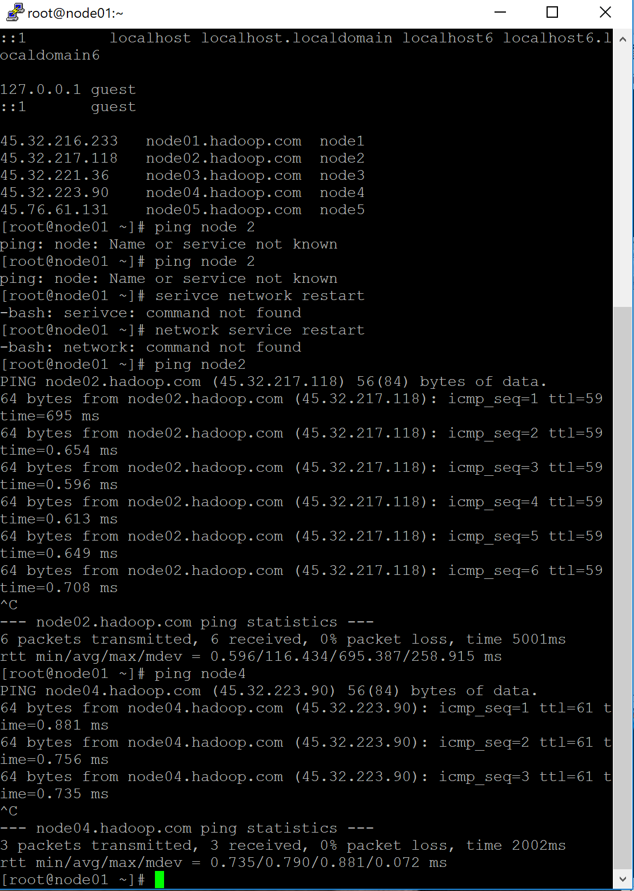

1. Updating all hosts etc/profile

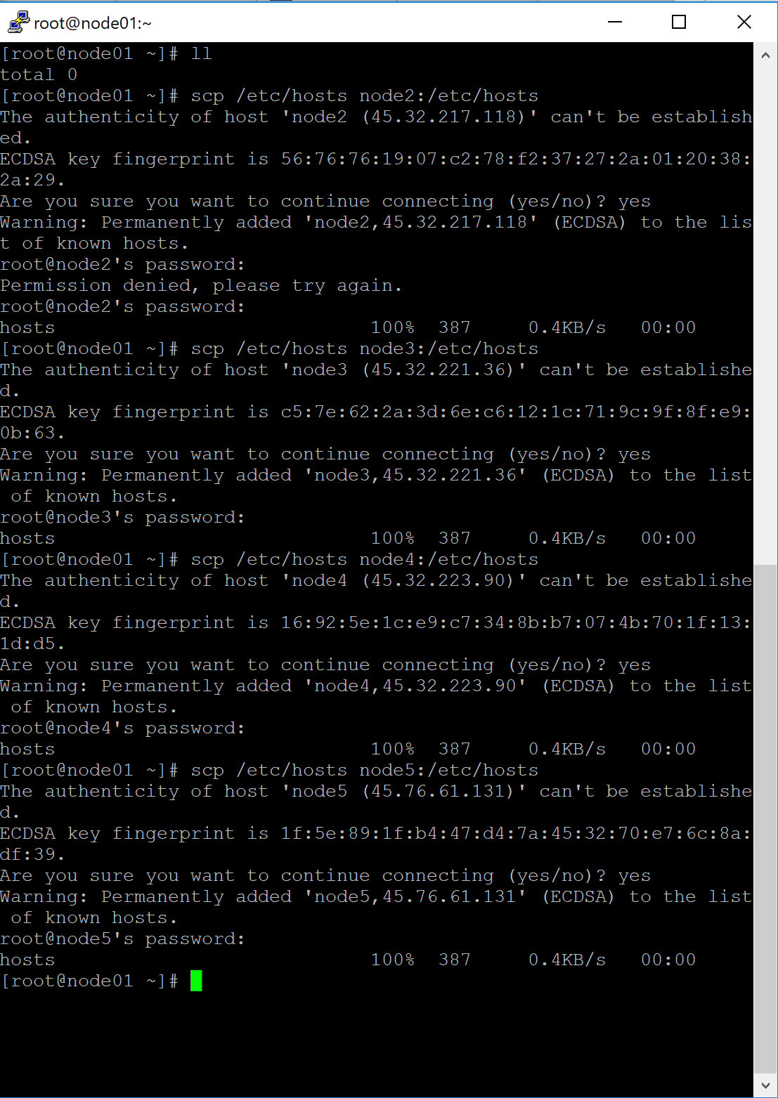

1. Setting SSH-KEYGEN on NODE1

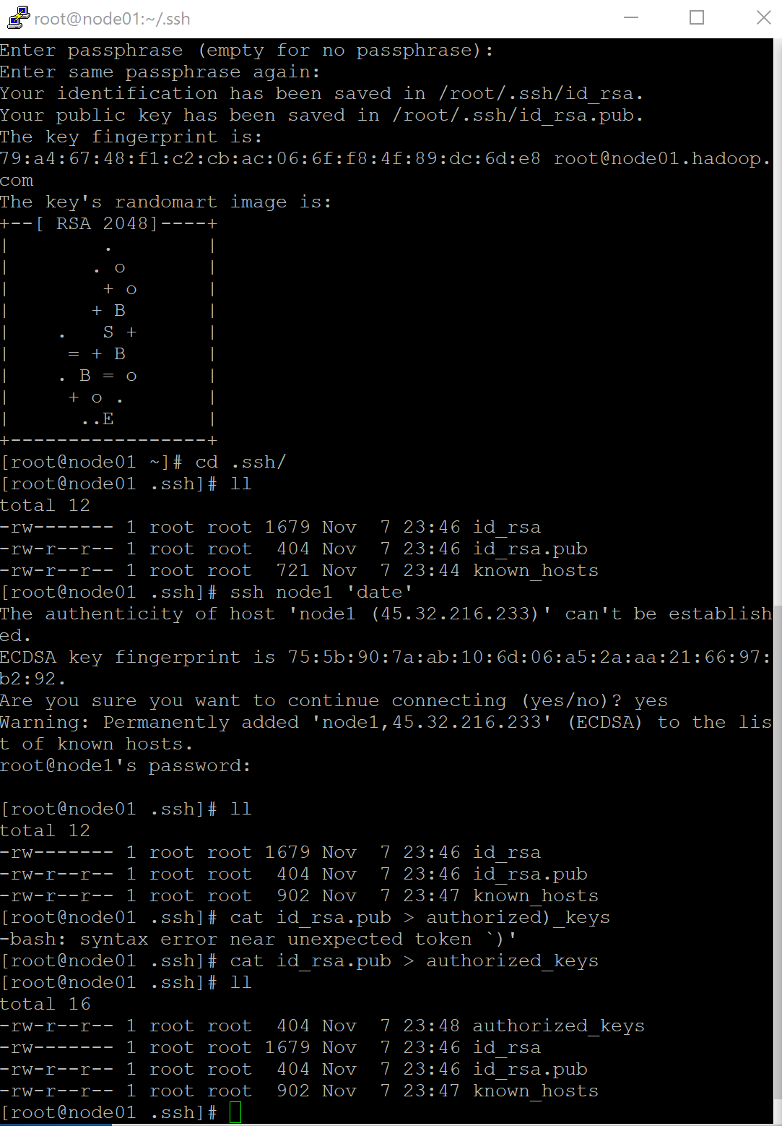

1. Setting SSH directory to copy AUTHORIZED_KEYS

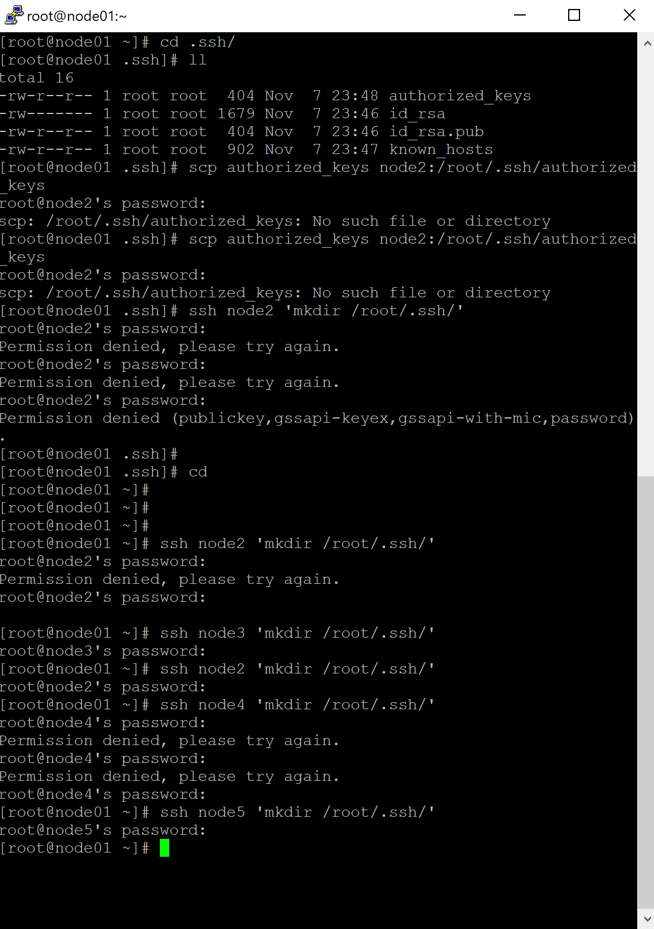

1. Successfully copies all Authorized_keys to all hosts

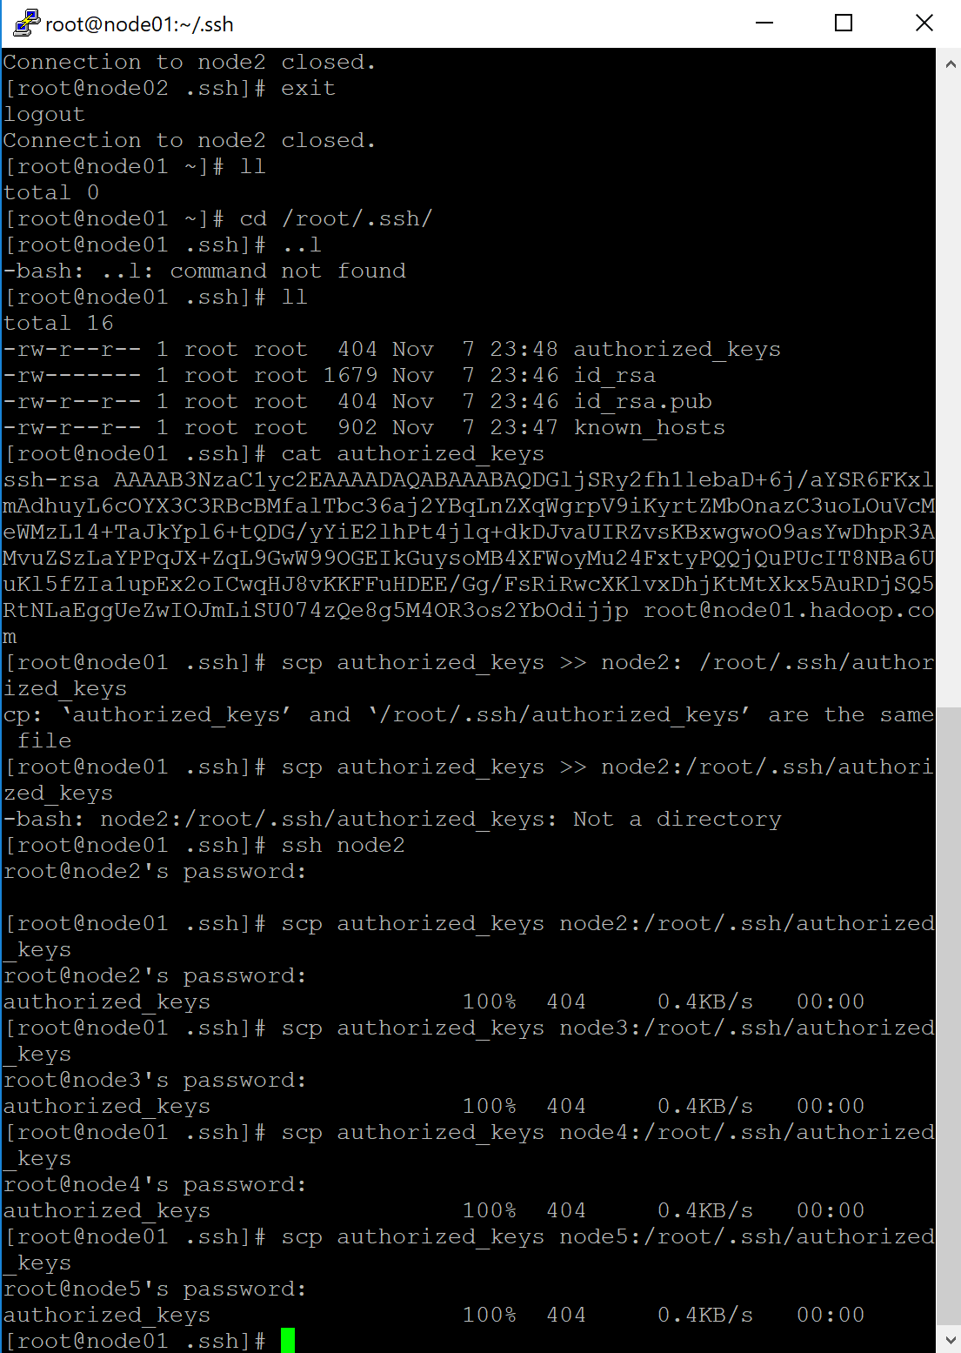

1. Checking if all nodes are accessible

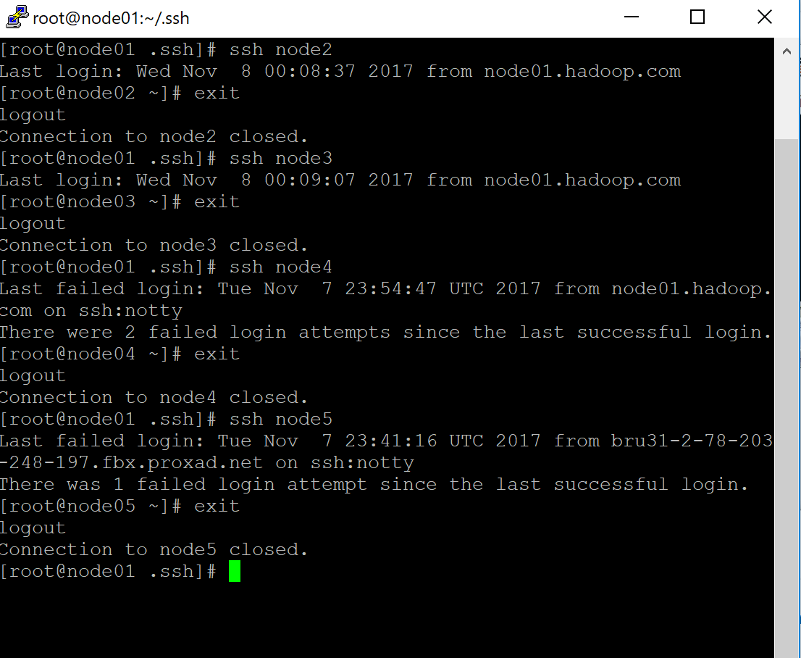

1. Using Execute_Command.SH

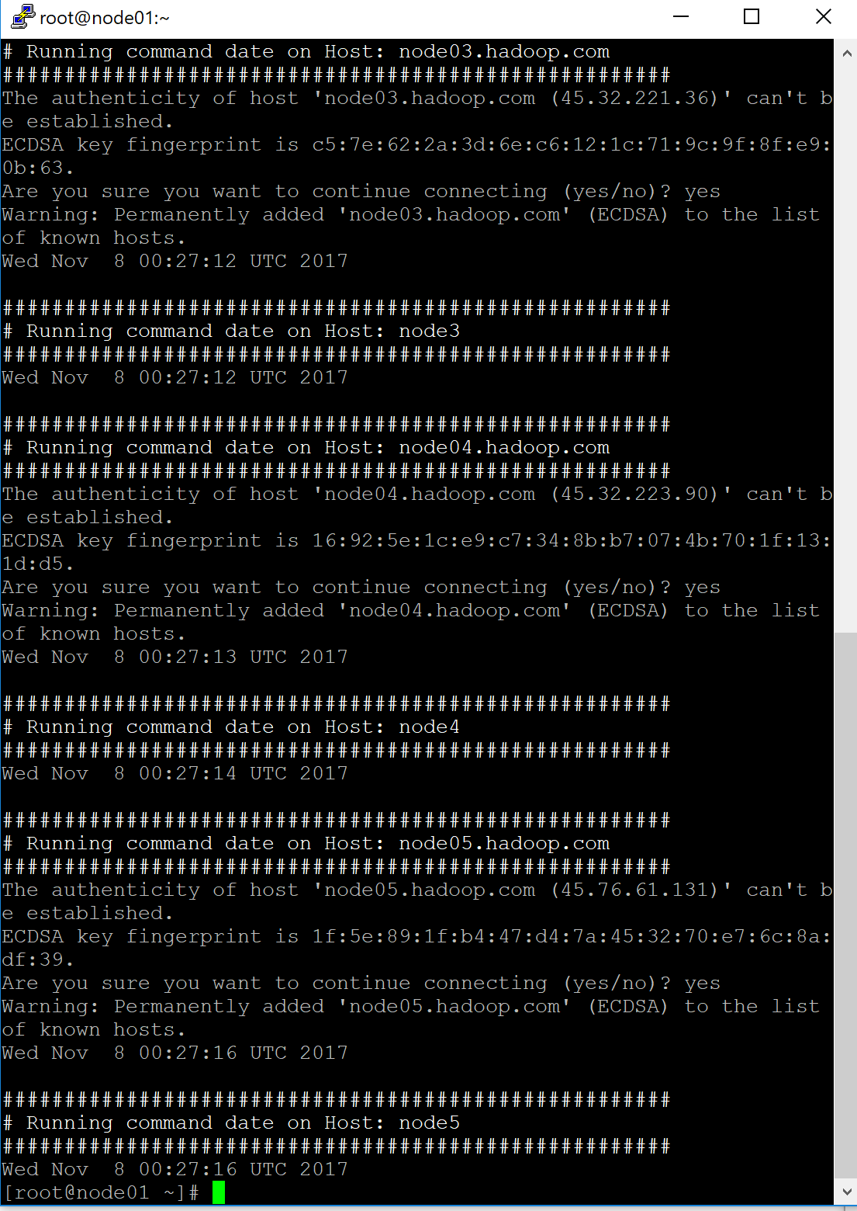

1. Downloading Java and Hadoop on Node 1 and then copying on ROOT of all nodes

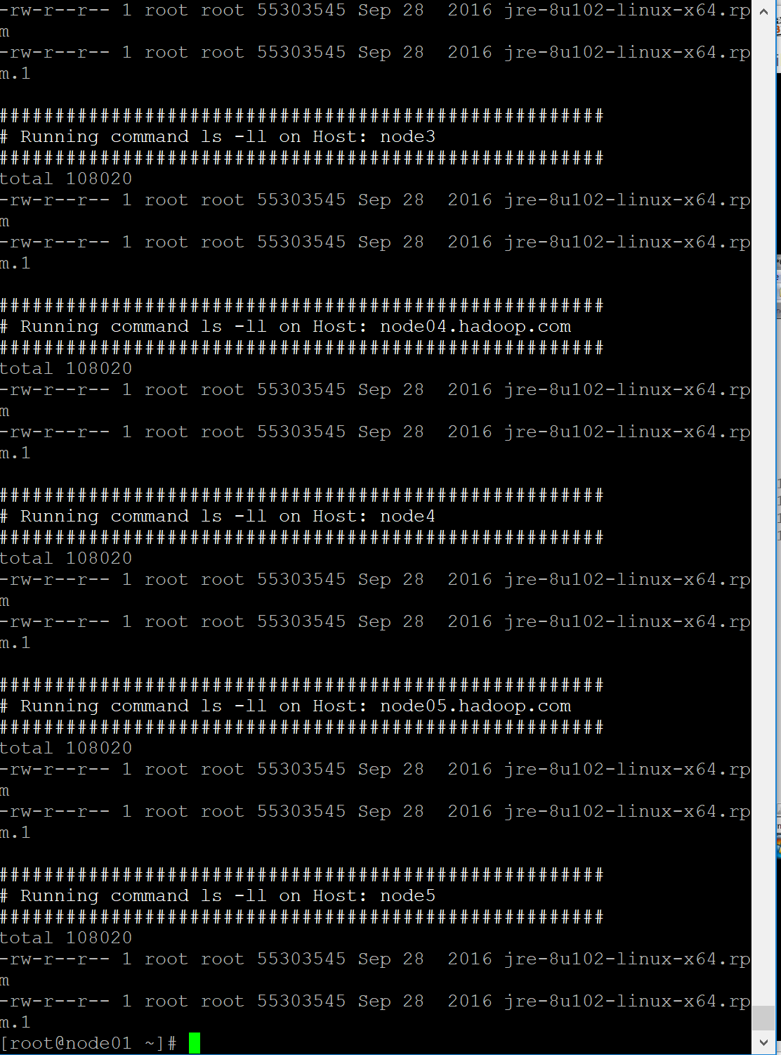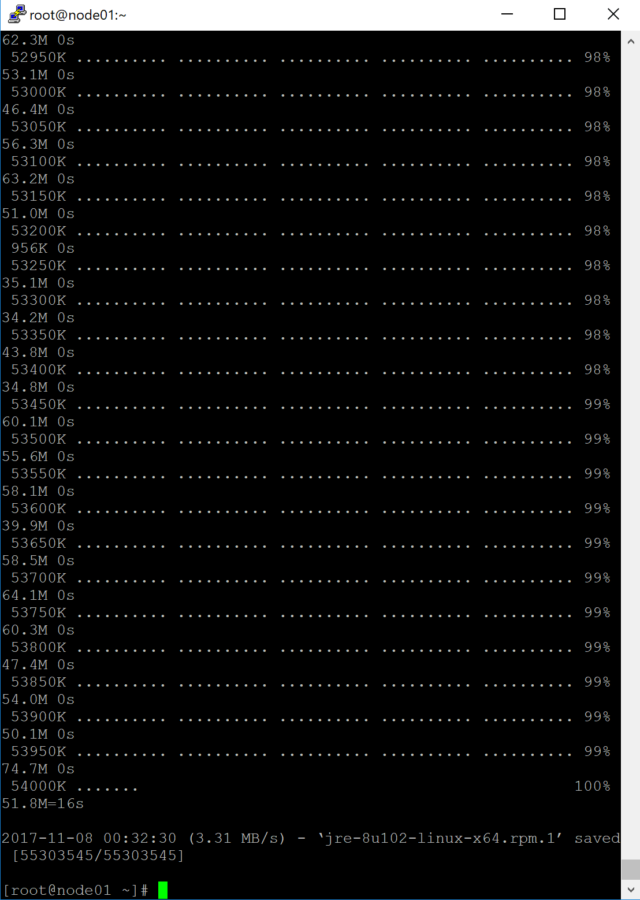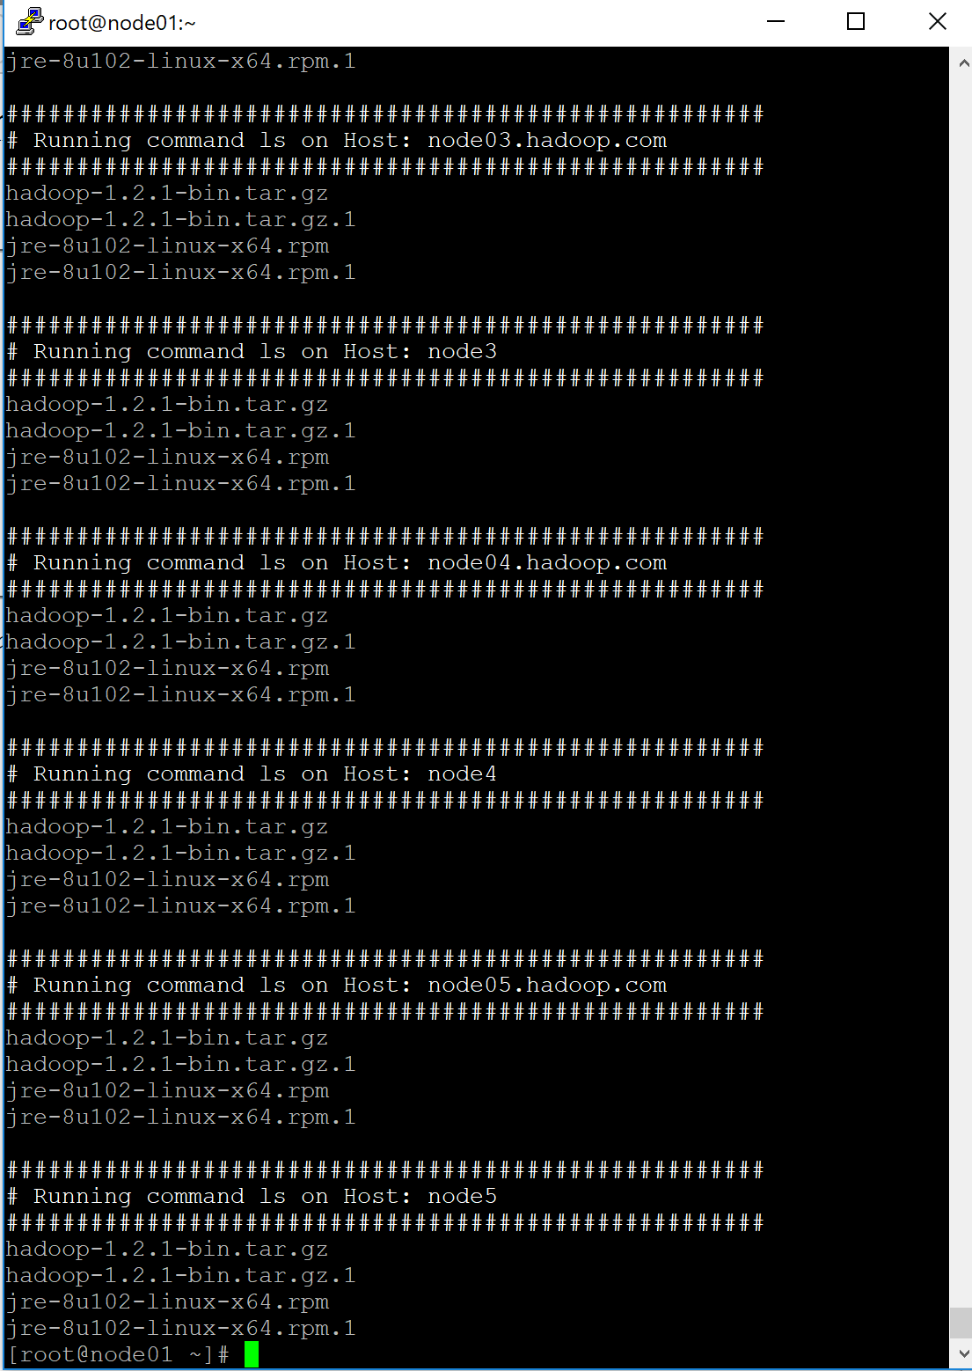

1. Creating Hadoop group and hduser client and creating SSH 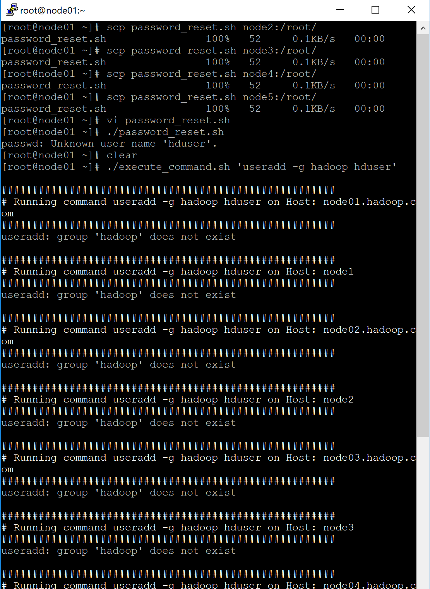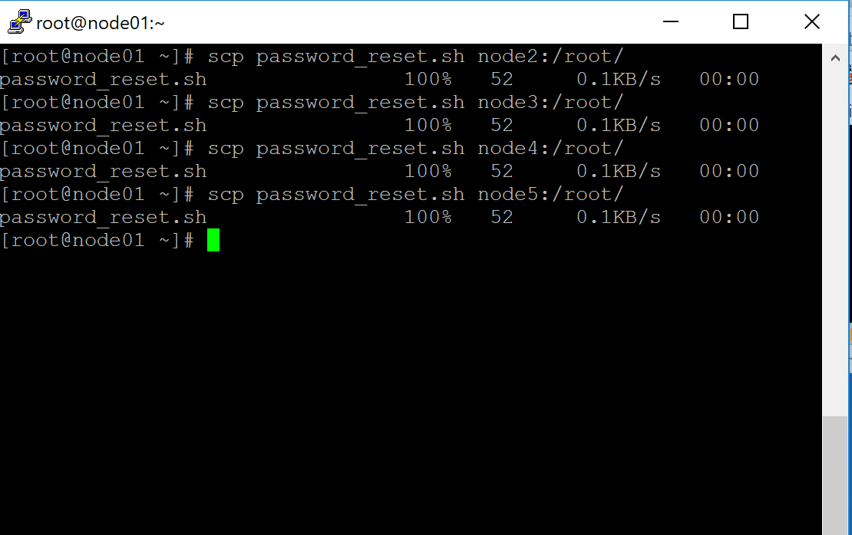
2. Doing SSH-KEYGEN for HDuser and copying Authorized _KEYS to all /usr/hduser/.ssh/ and accessing all nodes via hduser

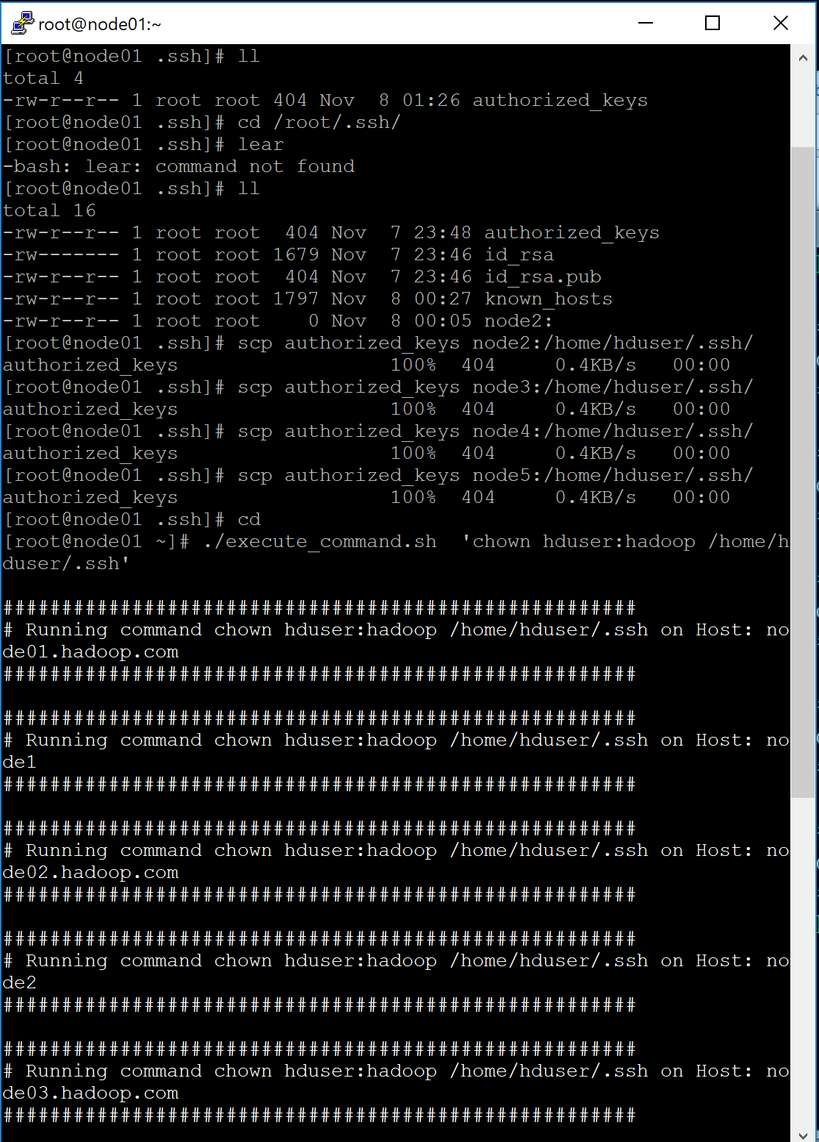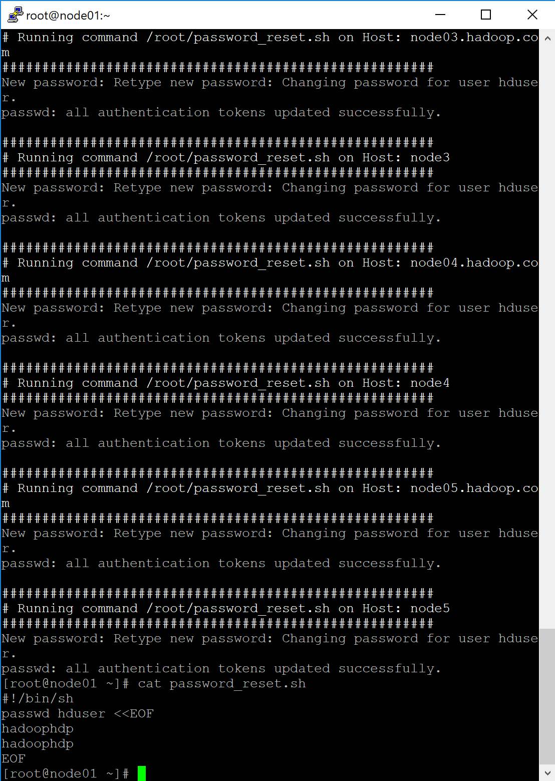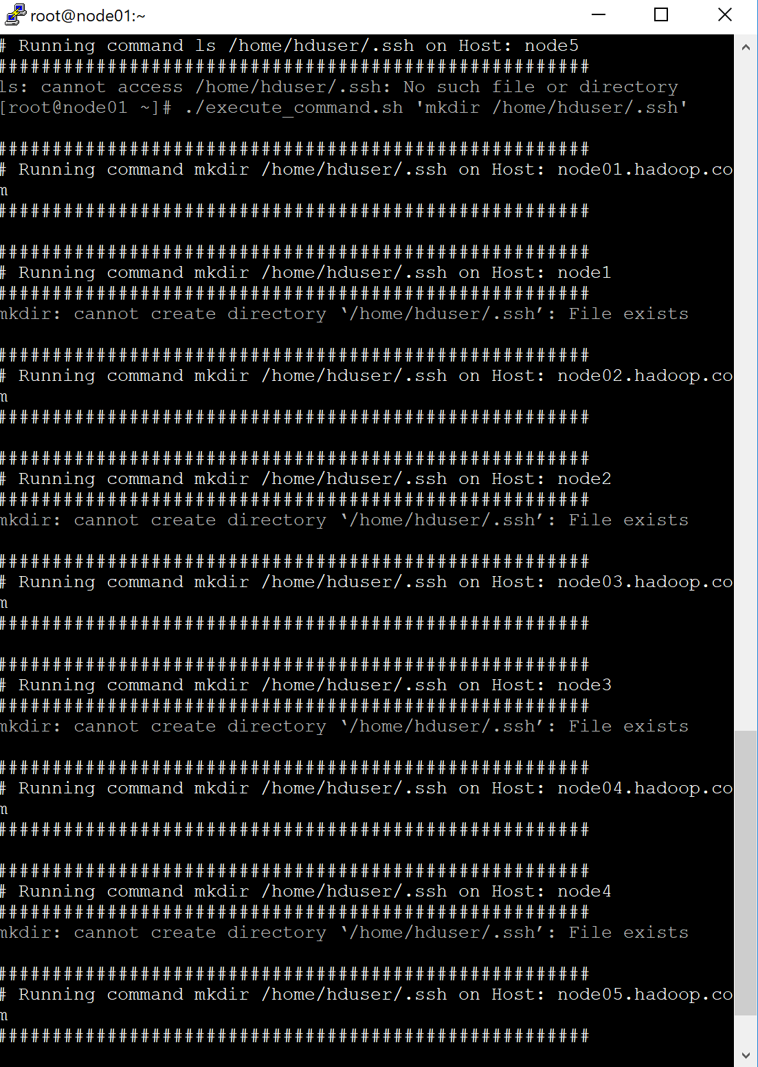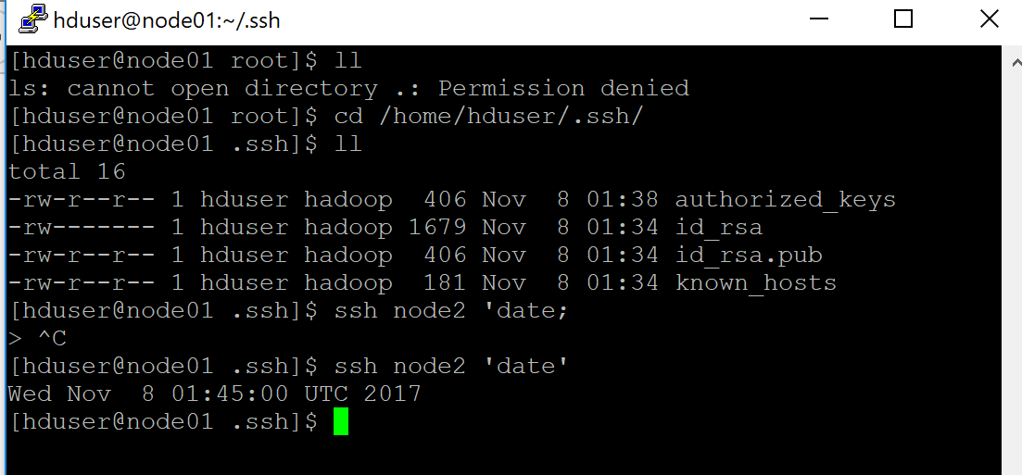

1. Installing Java and Hadoop on all machines /nodes

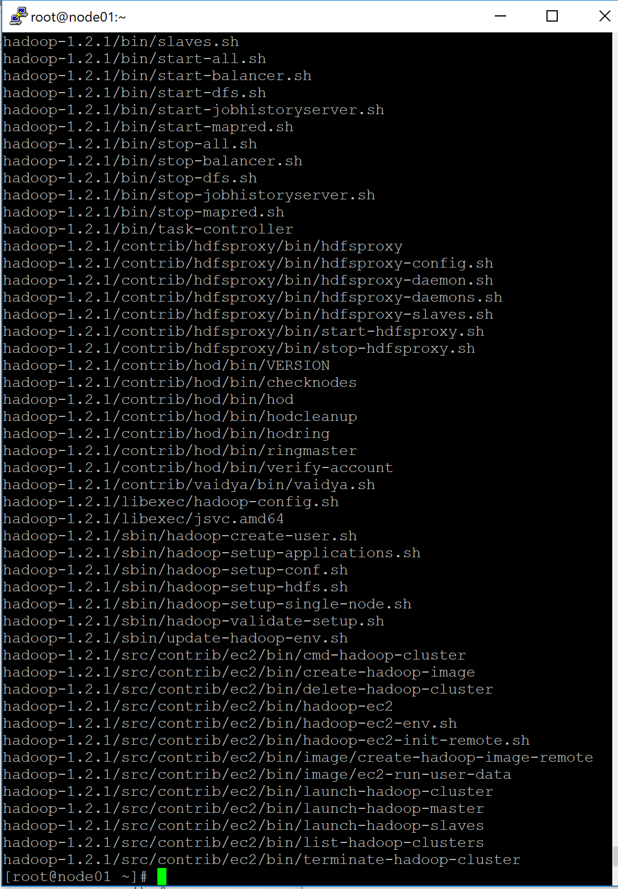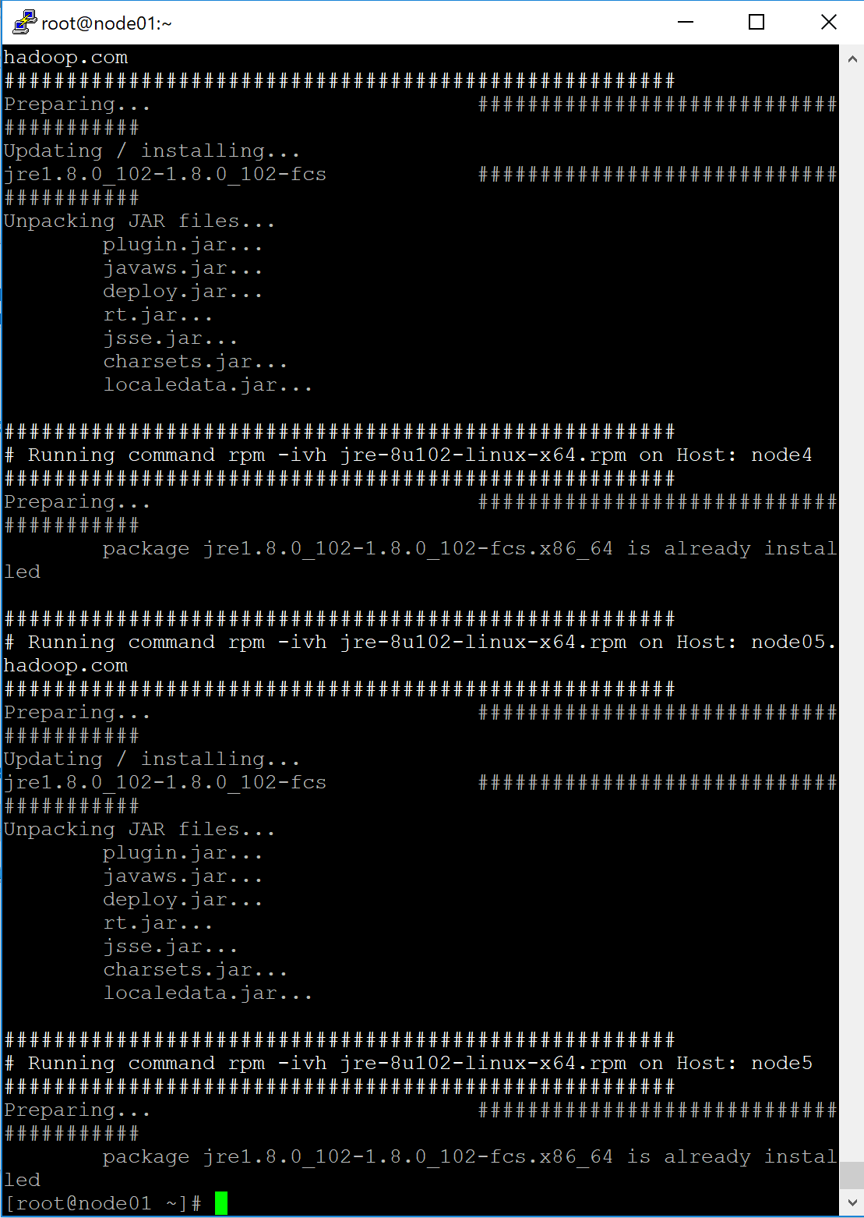

1. Setting Masters



1. Setting Slaves



1. Setting Hadoop Env

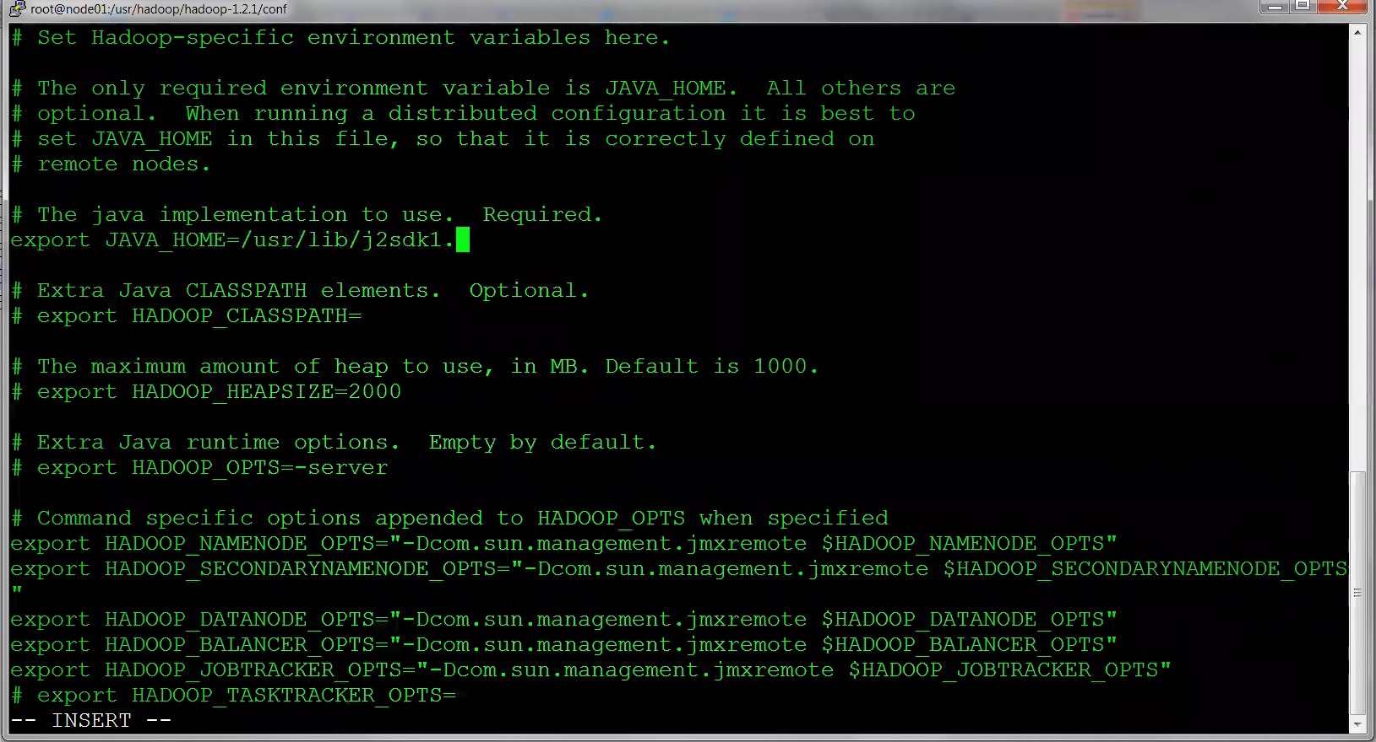

1. Setting Core-Site

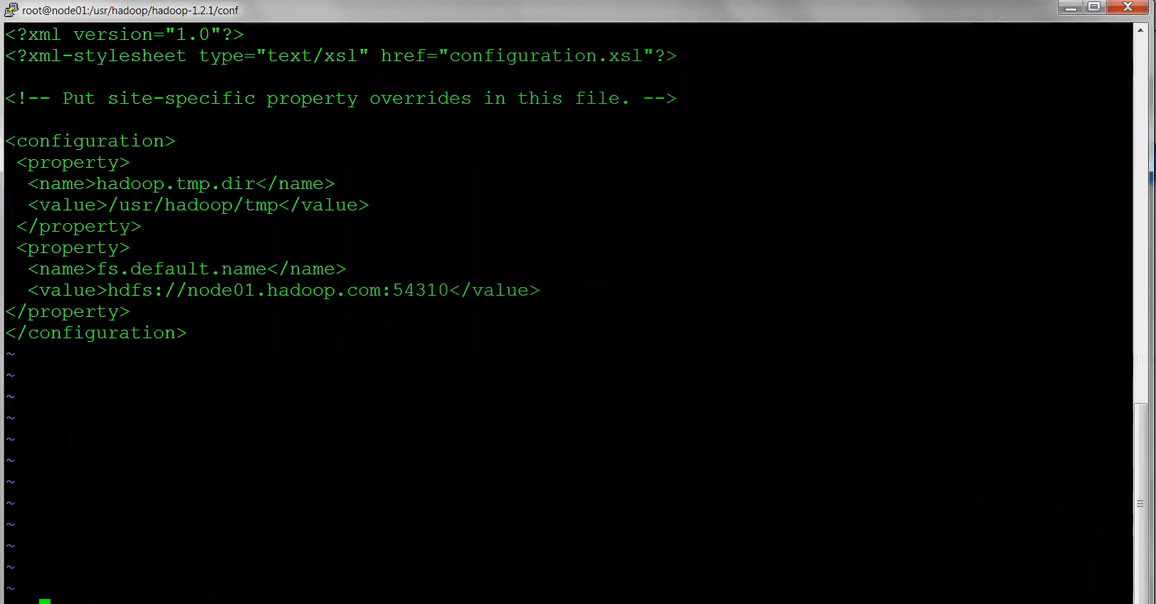

1. Setting Hdfs-site

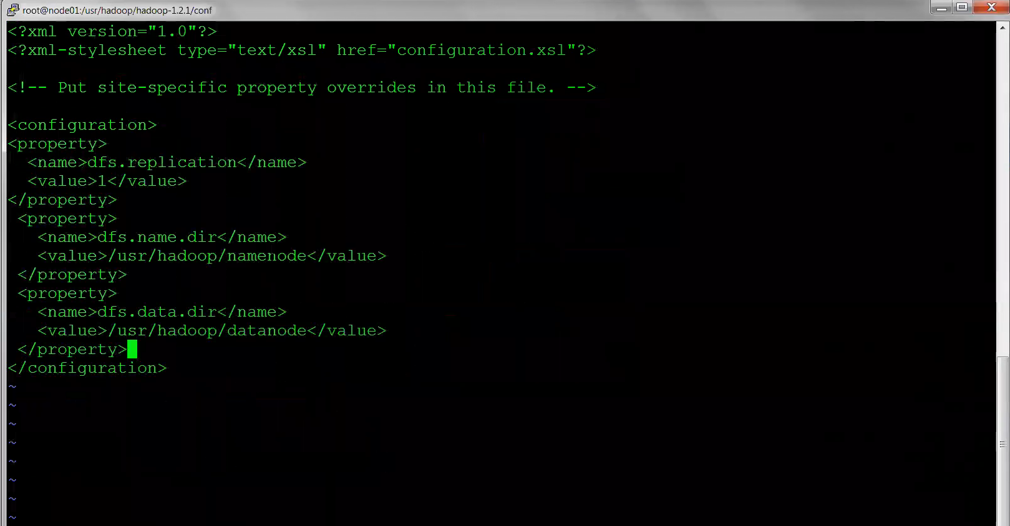

1. Setting Mapred-site

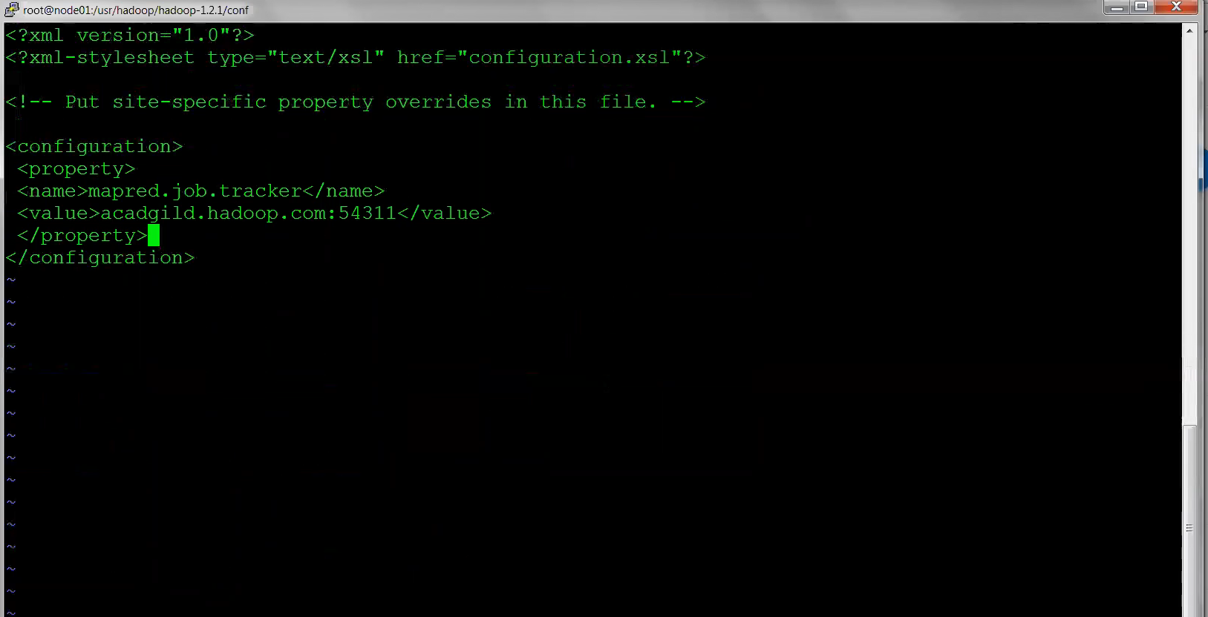

1. Copying all Hadoop Conf files to all relevant NODES /usr/hadoop/hadoop1.2-1/conf folders

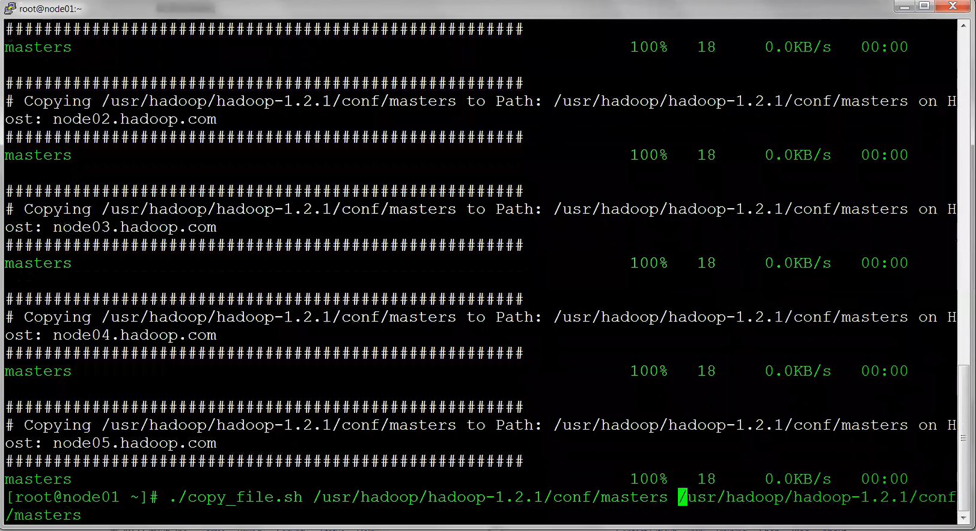

1. Creating and updating hduser ./bashrc (Setting JAVA_HOME and HADOOP_HOME softlinks/environments)

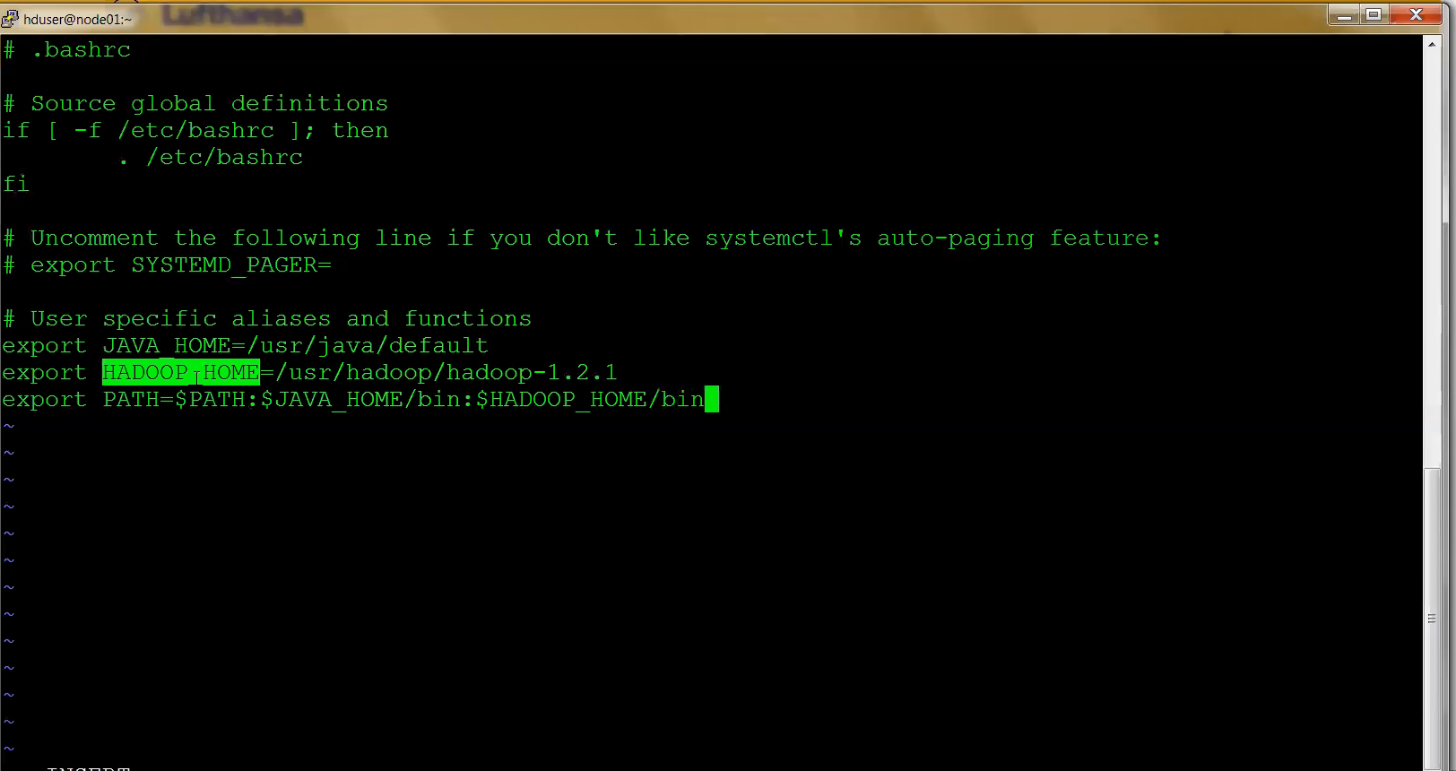

1. Formate Name node once you are done with this and checking the $PATH and Hadoop command

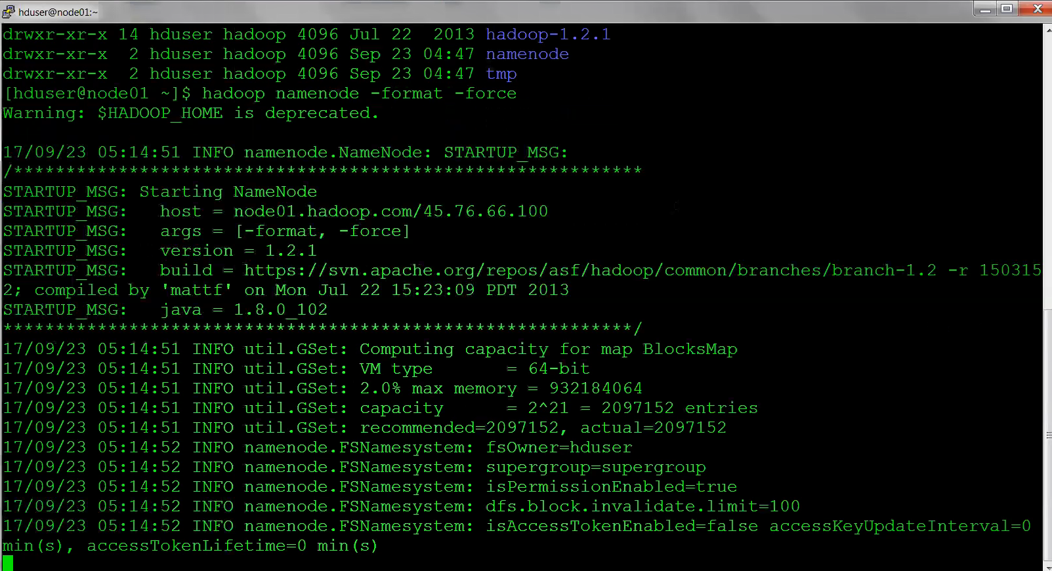

1. Stop Firewall

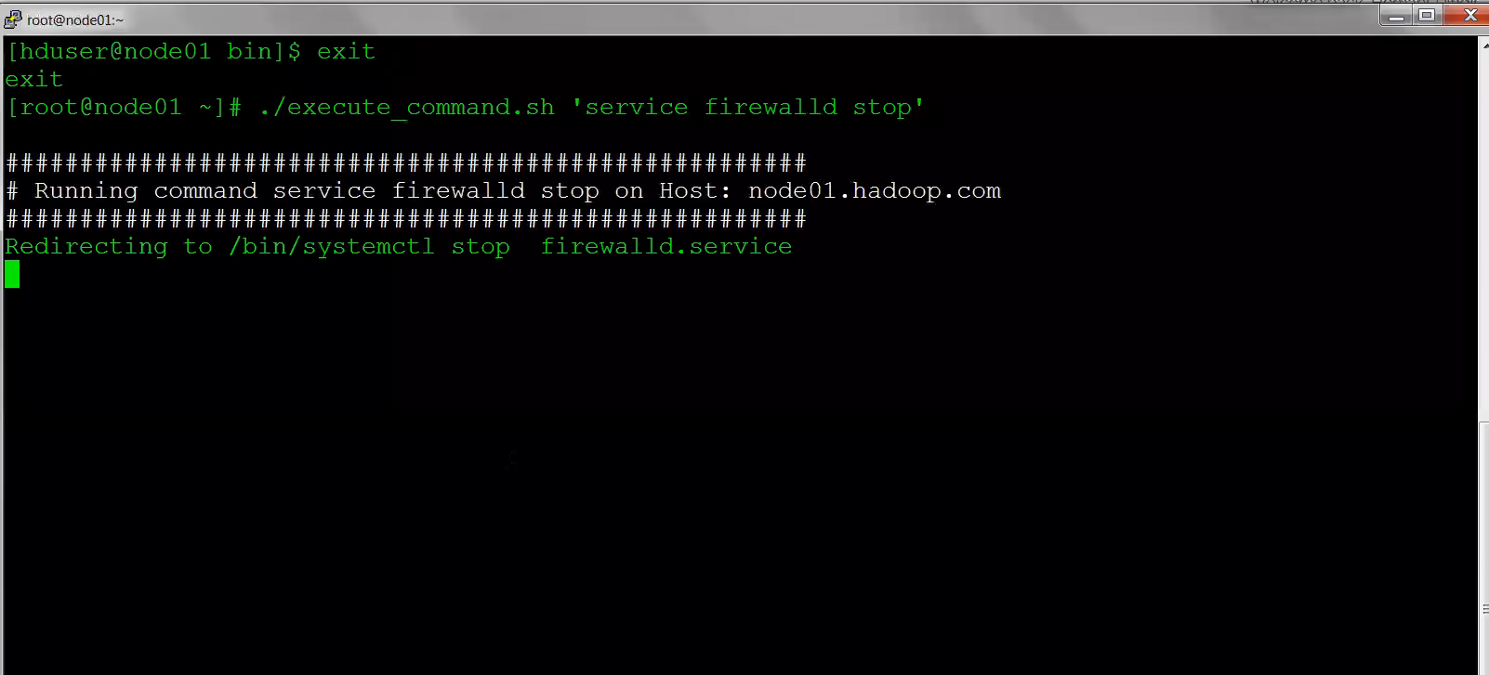

1. JPS on namenode

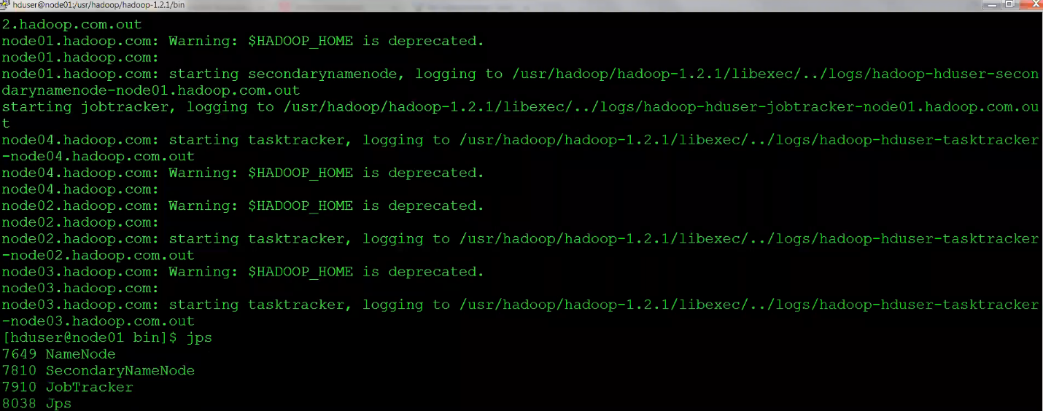

1. HD USER JPS

It wont show any thing but JPS only at their side

1. Checking nodes in brower

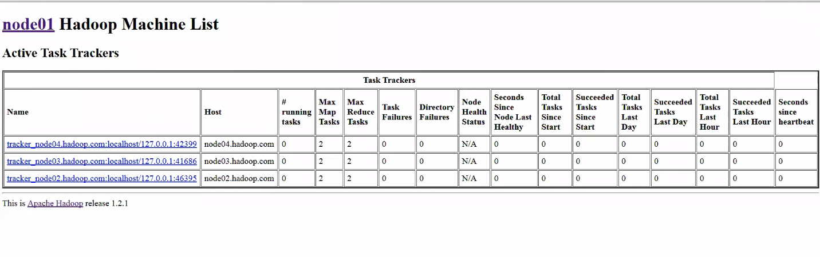

COMPLETE